# Title Information

Ishika Patel

Climate Change and Permafrost Lab 13

July 31, 2020

N/A

Table of Contents

Title Information 1

Data and Observations / Calculations 2

Arctic Polar Mapping Tool Questions/Action 2

Lab Question Answers 5

Activity 1: Summary 5

Activity 2: Data Lab Questions 6

Conclusions 11

References 11

# Data and Observations / Calculations

## Arctic Polar Mapping Tool Questions/Action

SOURCE: (Arctic Polar Mapping Tool, 2020)

|  |  |
| --- | --- |
| 1. Include your screenshot of AP Permafrost Classification: |  |
| 1. Include your screenshot of AP Permafrost Classification zoomed in on Alaska**. Using the legend of different colors that you can scroll through on the map legend, what are the top four categories of permafrost that you see covering Alaska?** | A screenshot of a computer  Description automatically generated  Via the legend, the top four categories of permafrost seen covering Alaska are in the legend colors of light-beige, dark-orange, dark-purple, light purple. Light-beige describes the category of discontinuous extent, low ice content and thin overburden. Dark orange describes the permafrost as discontinuous extent, medium ice content, thick overburden. Dark purple describes the permafrost as continuous extent, high ice content, thick overburden. The fourth most common category light purple in Alaska describes continuous extent, low ice content and thin overburden. |
| 1. Include your screenshot of Permafrost Extent zoomed in on Alaska. Covering the state of Alaska, **describe the permafrost extent that you see, try to include at which latitude lines you see from** **Figure 2 in your description.** | A screenshot of a computer  Description automatically generated  Beginning at 70 degrees North right near the Beaufort Sea, the permafrost extent is continuous. Moving towards the Arctic Circle we see continuous extent to discontinuous between 140 degrees west and 160 degrees west. At 60 degrees north we get discontinuous to sporadic extent. Then from 60 degrees north to 50 degrees north we see the movement from isolated patches of permafrost ending in a stretch of glaciers. |
| 1. Include your screenshot of AP_Boreholes in Alaska. **Why do you think scientists placed the boreholes where they did?** | A screenshot of a computer  Description automatically generated  Boreholes are for the use of measuring underground permafrost. For this reason, the deeper boreholes are located in the continuous permafrost extents of Alaska. Moving out as the gradient get lesser in terms of extent, the dept of the borehole lessens as well. The deep boreholes are at 90 degrees north latitude and between 140 degrees west and 160 degrees west longitude. The depths of the boreholes all occur around one another. |
| 1. Use this map tool to investigate other layers while focusing on Alaska. **What layers did you investigate? And what did you notice about the certain regions regarding that layer?** | A screenshot of a computer  Description automatically generated  The layers I chose to investigate include the Demography of Arctic Peoples with the Oil and Gas layered on top. Something I have always found important is honoring the culture of native lands. There are so many native tribes that have been impacted by oil and gas. In recent times the Alaskan pipeline broke headlines of being built. People impacted shown in the simulation include: North Alaskan Inupiaq, Siglitun, Inuinnaqtun, Inupiaq, Tanacross, Holikachuk and Dogrib peoples. This list is only some of the peoples I could identify which demonstrates the depth at which the oil and gas industry impacts Alaska. |

# Lab Question Answers

### Activity 1: Summary

The article I chose to look into discusses the topic of how the people of Alaska are being affected by the warming permafrost. The article I chose is from the Climate Reality Project titled “How is the Climate Crisis Affecting Alaska?”. I points Alaska as grounds zero to the crisis meaning that Alaskan people are seeing the worst of the climate crisis impacts. Beginning with record breaking temperatures to the rapidly melting ice these climate related instances are adversely impacting the people. One particular tradition that’s has been thrown off is whaling. This practice of hunting whales by most notably the Utqiaġvik people is sending whalers deeper into the depths of the sea. By this means, the Alaskan people are seeing a real shortage of food. This is a deeply concerning problem for the already isolated Alaskans. Like many the Yupik are having to relocate after the permafrost they settled on began to thaw. Their land will soon become a river and has out 400 native Yupik from their homes. With warming temperatures, Alaskans are seeing wildfires and sinkholes developing, further displacing them and destroying their glorious ecosystem. Culturally, Climate change has been wiping out native Alaskans from relocation to the fear or eventual starvation. Unfortunately, these affects do not seem to be slowing down at any moment soon. Scientists are worried about waking viruses and methane escaping making wildfires the least of the eventual worries.

The Climate Reality Project. (2020, March 11). How Is the Climate Crisis Affecting Alaska? Retrieved July 31, 2020, from <https://climaterealityproject.org/blog/how-climate-crisis-affecting-alaska>

### Activity 2: Data Lab Questions

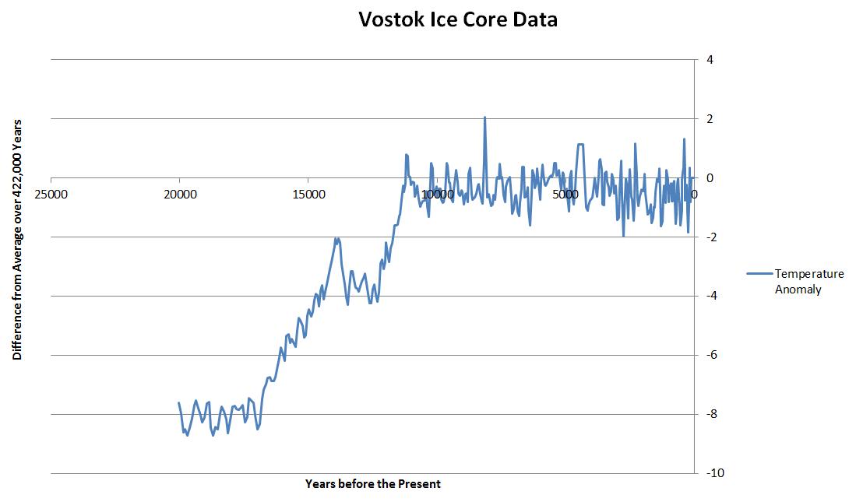

**Fig. 2:** Source: Petit, J.R., et al., (2001). Vostok Ice Core Data for 420,000 Years, IGBP PAGES/World Data Center NOAA/NGDC Paleoclimatology Program, Boulder CO, USA.

1. **For approximately how many thousands of years has the Earth been in the peak of an interglacial period within the present ice age?**

An interglacial period is the period of warmer global temperatures, as measured by the averages and the anomalies in the Vostok Data. The peak of this graph beginning around 11,000 years before present, this the approximately how many thousands of years has the Earth been in the peak of an interglacial period within the present ice age.

1. **How much higher has the average temperature during the peak of the interglacial period been compared to the average temperature during the last glacial maximum?**

The most notable anomaly data points of the Ice Core over the year begins around 20,000 years ago where the temperature anomaly was approximately -8. The highest temperature average anomaly is around 7500 years before the present where there is a peak at a difference of 2. These are the two most prevalent outliers in the difference from the average temperatures.

1. **What could be the major change that could have happened during this time period? (Hint: you can look through your chapter reading or on the internet – just be sure to cite any sources used.)**

According to the chapter reading some different changed that contribute to climate change include plate tectonic movement and continental positioning. Something specific that caught my eyes was the Anthropogenic Climate Change. This attest lots of warming to our usage of fossil fuels (Earle, 2015). Ranging from early agriculture 10,000 years ago to the most recent industrial revolution we have been contributing to warming. Breakdown of permafrost has also been a contributor to increased methane in the atmosphere. Other human changes such as infrastructure impact the average albedo number of Earth making it more likely to keep heat as opposed to reflect.

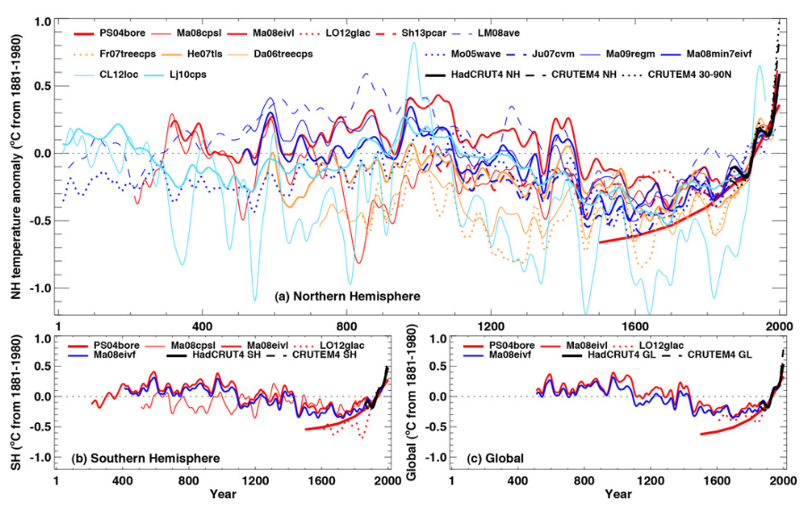**Fig. 3:** The reconstruction of annual temperatures of the Northern Hemisphere in the last 2000 years, representing anomalies (°C) from the 1881-1980 mean (horizontally dashed line). Source: IPCC Assessment Report 5 (2013), Chapter 5, Fig. 5.7

1. **Examine all of the reconstructed temperatures for the Northern Hemisphere (top graph). Are there other periods that appear to be as warm as the period of 1950 to 2000? (Note that instead of looking at a single study, which could be an outlier, try to focus on groups of studies that show similar patterns. Using a straight edge might help to determine the approximate date(s).)**

The period of 1950 to 2000 is the last 1/8 unit of the x-axis on the Northern Hemisphere graph. This period is characterized by great exponential positive increase in temperature. There are multiple areas where the temperature rise seen in the last 50 years is similar in a different time period. We see similar heightening in temperature around year 550 as well as around year 700, and year 1300. Period where the temperature was just as high include in year 900 in the Lj10cps study. Also, the 1950-2000 trend in the CL12loc study shows a different downwards parabola trend with the same heightened temperature.

1. **Approximately how much warmer (e.g. 0.5° C, 1° C, etc.) was the warmest 50-year period than the coldest 50-year period? When was that high and low?**

The warmest 50-year period globally categorized by a constant high temperature anomaly was the year interval between 1950 to 2000. This period has a height of 0.7 degrees Celsius increase in global temperatures. The coldest 50-year period globally categorized by a constant decrease in temperature anomaly was the year interval between 1450 to 1500 with a lowest deviation reaching approximately -0.4 degrees Celsius. These approximations make the warmest 50 years period approximately 1.1 degrees Celsius hotter than the coldest 50-year period in anomalies.

1. **What possible major factor do you think could have caused the differences between the warmest and coldest 50-year periods? (You might need to look research what was going on during that time period and give any source.)**

Some major factors that I have read in the textbook include the increased use of fossil fuels. This is a massive culprit of increasing average global temperatures. With melting icecaps, we are also seeing a release in methane and other organic materials. Another factor is the sheer increase in sun exposure we have been seeing. With an increase of heat kept wining our atmosphere rather than bounced off our ozone, there is a massive increase in average fermetures.

1. **Examine the Global temperatures now (bottom right graph). Where do you see the greatest change occurring?**

Something that I found very interesting was the general trend of cooling form year 400 to around the year 1700 on the x-axis. This was neat but makes complete sense as modern civilization did not kick up until recently in our grand scheme of time. I remember something silly like present day being closer to the age of Cleopatra than Cleopatra being to the early Mammoths, and this tells us so much about the trend of time. Ever since around 1700 the trend in global temperature has been increasing and with hat very rapidly. Closest to present day is where the greatest creates change is occurring.

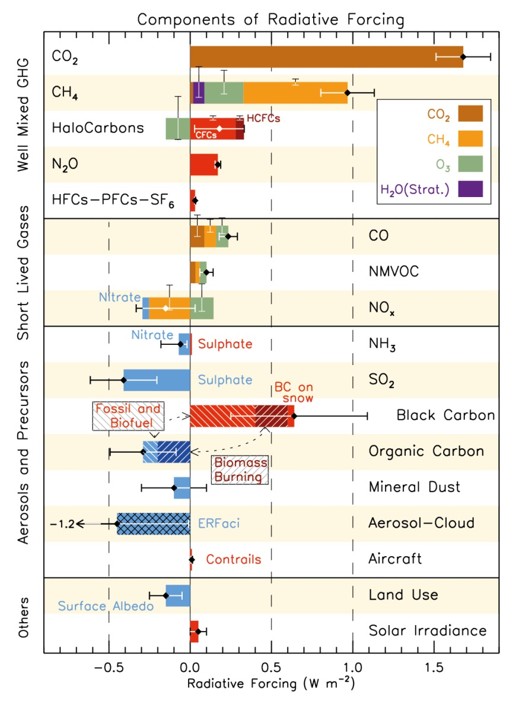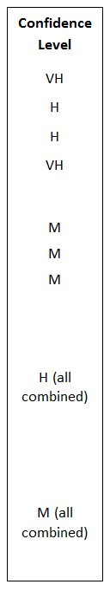

**Fig. 4**: Source: IPCC Assessment Report AR5-WG1 (2014), Chapter 8, Fig. 8.17

1. **In Fig. 3 the reconstructed temperatures indicate that the amount of global warming from 1750 to the present (or 2011) was close to 1° C. As noted in Fig. 4 there are various drivers, both anthropogenic and natural. From looking at Fig. 4 which category of factors do you think was the primary driver during that time period?**

During this time period where the amount of global warming from 1750 to the present (or 2011) was close to 1° C, the categories of factors I think are the primary driver include: CO2, CH4 and Black Carbon. These are the top three categories of positive radiative forcing.

1. **What is the largest contributor of all of the radiative forcing?**

The largest contributor of all the radiative forcing is CO2at around positive 1.7 and a very high confidence level.

1. **Which radiative forcing estimates do researchers have the most confidence in?**

Researchers have the most confidence in CO2 and N20 forcing estimates. These two have Very High confidence levels. Other with High confidence levels include: CH4, and Halocarbons,­­­­­­ as well as NH3, SO2, Organic + Black Carbon, Mineral Dust, Aerosol, and aircraft all combined.

1. **Which radiative forcing estimates do researchers have the least confidence in?**

Researchers have the least confidence in CO, Land Use and Solar Irradiance forcing estimates with medium levels. However, something interesting to notice is how the Black Carbon has the largest standard deviation in RF values so this should be noted.

1. **What is the second highest well-mixed greenhouse gas when it comes to radiative forcing? And what is the approximate difference in radiative forcing between it and the highest?**

CH4 is the second highest well-mixed greenhouse gas when it comes to radiative forcing. It has an approximate RF value of 0.95. The highest is CO2with and RF of 1.7. This makes an approximate difference of +0.75 in radiative forcing between it and the highest.

1. **From the Aerosols and precursors category, why do you think things such as black carbon has the opposite radiative forcing?**

Something to notice in the chart is that Black Carbon is exhibited on snow and is fuels and biofuels. The distinct color, being black, is the biggest reason it has an opposite radiative forcing! With a lower albedo it has less potency in reflecting light as compared to something like the white aerosols (Earle, 2015). According to the Lab Intro, “Black carbon, which as its names implies is a dark substance, emitted in the middle and high latitudes can get deposited on snow and ice, decreasing the albedo of snow and ice.”

1. **What three greenhouse gases had the largest positive radiative forcing among all the forcing agents?**

Among all the forcing agents, the three greenhouse gasses that had the largest positive radiative forcing in order are CO2, CH4 and Black Carbon.

# Conclusions

In truly understanding the impact of Climate Change I looked toward some novel climate activists. In one of my other courses I watched a Jane Goodall video on the glorious features of our planet and how we are destroying them. In an attempt to begin changing my habits I looked towards taking shorter showers and watching my dorm room thermostat on top of the small habits I already had like keeping the sink off as I brush my teeth and turning off lights in rooms, I am no longer in. These habits while helping a bit are clearly not addressing a deeper issue.

Beginning with activity 1, I learned about permafrost and its melting and how this impact our world. Truth be told, before this lab I did not exactly know what permafrost is. Now I can discuss how it is a surface which is frozen for an extended period of time: rock, ice, organic compounds and more. Permafrost melting is not only an issue to the climate but also the people and cultures of folks who live in permafrost areas. Alaskan natives are being displaced due to melting and their traditions are becoming more dangerous to uphold. More than that we could possibly see a new virus emerging from within the permafrost and an increase in sinkholes and more flooding.

With this problem identified, I moved onto activity 2 which discussed more in detail greenhouse gases. A new term I learned was RF which essentially measures how bad of an impact a certain greenhouse gas has on the planet. From CO2 to SO3 we see varying RF values that describe the level of impact. A term I was happy to come across for the second time was albedo. On Earth, we want high albedo or lighter materials which are able to reflect light well. This section was eye opening at the true impact and the sheer confidence researches has in this bad impact of greenhouse gases int eh warming process.

This lab was a great online look into the facets of climate change. In my real-life application this got me to think how I can push myself to decrease my carbon footprint and help others do the same!

# References

Arctic Polar Mapping Tool. (2020). Retrieved July 31, 2020, from <http://portal.inter-map.com/>

Earle, S. (2015, September 1). Physical Geology. Retrieved June 8, 2020, from <https://opentextbc.ca/geology/>

The Climate Reality Project. (2020, March 11). How Is the Climate Crisis Affecting Alaska? Retrieved July 31, 2020, from <https://climaterealityproject.org/blog/how-climate-crisis-affecting-alaska>